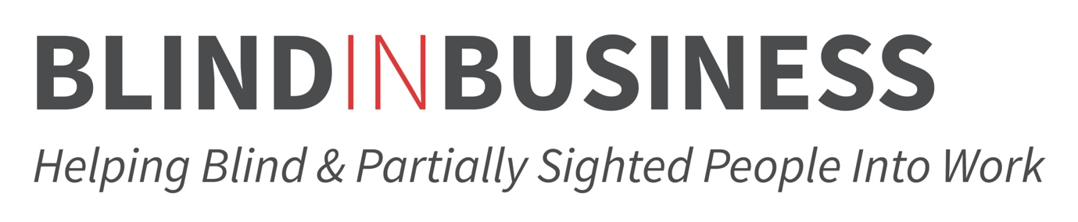

How to access our support:
If you would like to keep in touch with us, fill in your details below and we will get in touch with you via email. This is for our use only, so that we can provide you with the best support and stay in contact with you easily.
Send this form to jess@blindinbusiness.org.uk

Name and surname:
My QTVI:
Telephone:
Email:
School:
Age:
Signature from parent/guardian/teacher (if under 16):

For all students, we only retain the above personal data for the benefit of the student whilst working with them. For any students under the age of 16, we require permission from a parent/guardian/teacher to retain this data. Your data is treated as confidential and only Blind in Business staff will have access to this information. If you wish for your data to be destroyed, please contact us.

